WEEK1:- Implement the data link layer framing methods
a) Bit stuffing
b) Character Stuffing

// Bit stuffing
include<stdio.h>
#include<string.h>
int main()
{
char data[50], stuff[50], dstuff[50];
int i,j, cnt,len;
printf("enter data\n");
scanf("%s",data);
len=strlen(data);
cnt=0;
j=0;
for(i=0;i<len;i++)
{
if(data[i]=='1')
{
cnt++;
}
else
{
cnt=0;
}
stuff[j]=data[i];
j++;
if(cnt==5&&data[i+1]=='1')
{
stuff[j]='0';
j++;
cnt=0;
}
}
stuff[j]='\0';
printf("stuffed data at intermediate site is \n 01111110 %s 01111110 \n",stuff);
//destuffing
len=strlen(stuff);
cnt=0,j=0;
for(i=0;i<len;i++)
{
if(stuff[i]=='1')
{
cnt++;
}
else
{
cnt=0;
}
dstuff[j]=stuff[i];
j++;
if(cnt==5&&stuff[i+1]=='0')
{
cnt=0;
i++;
}
}
dstuff[j]='\0';
printf("destuff data: %s",dstuff);
}

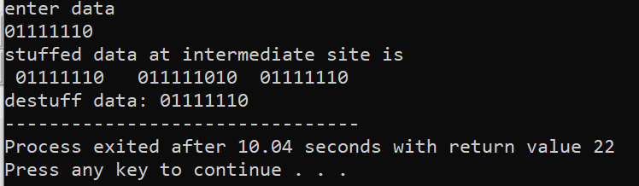
********************************************************************************

// b)Program to implement byte stuffing
#include<stdio.h>
#include<string.h>
void main()
{
char frame[50][50], str[50][50];
char flag[10];
strcpy(flag,"flag");
char esc[10];
strcpy(esc,"esc");
int i,j,k=0,n;
strcpy(frame[k++],"flag");
printf("enter no. of strings\t");
scanf("%d",&n);
printf("enter string\n");
for(i=0;i<=n;i++)
{
gets(str[i]);
}
printf("you entered\n");
for(i=0;i<=n;i++)
{
puts(str[i]);
}
printf("\n");
for(i=1;i<=n;i++)
{
if(strcmp(str[i],flag)!=0 && strcmp(str[i],esc)!=0)
{
strcpy(frame[k++],str[i]);
}
else
{
strcpy(frame[k++], "esc");
strcpy(frame[k++],str[i]);
}
}
strcpy(frame[k++],"flag");
printf("-----------\n");
printf("Byte stuffing at sender side:\n\n");
for(i=0;i<k;i++)
{
printf("%s",frame[i]);
}
}

Output:-
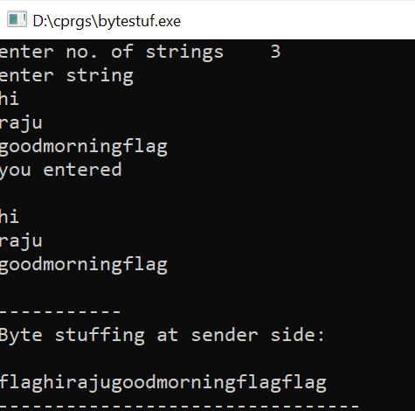

Week3:
//hamming distance
#include<stdio.h>
#include<string.h>
void main()
{
char bit1[100],bit2[100];
printf("enter datawor d1 and datawor d2 of same length");
scanf("%s%s", &bit1,&bit2);
int i, count=0,len;
len=strlen(bit1);
for(i=0;i<len;i++)
{
if(bit1[i]!=bit2[i])
{
count++;
printf("error at position:%d\n",i+1);
}
}
printf("hamming distance is %d",count);
}
Output:-

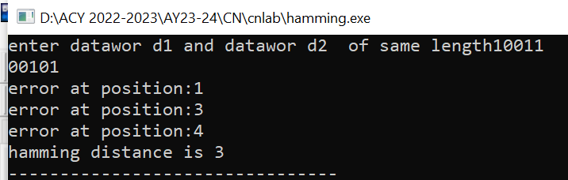

**********************************************************************************

Week2:
//Implement CRC mechanism

#include <stdio.h>
#include <string.h>
void main()
{
int i,j,keylen,msglen;
char input[100], key[30],temp[30],quot[100],rem[30],key1[30];
printf("Enter Data: ");
gets(input);
printf("Enter Key: ");
gets(key);
keylen=strlen(key);
msglen=strlen(input);
strcpy(key1,key);
for(i=0;i<keylen-1;i++)
{
input[msglen+i]='0';
}
for(i=0;i<keylen;i++)
temp[i]=input[i];
for(i=0;i<msglen;i++)
{
quot[i]=temp[0];
if(quot[i]=='0')
for(j=0;j<keylen;j++)
key[j]='0';
else
for(j=0;j<keylen;j++)
key[j]=key1[j];
for(j=keylen-1;j>0;j--)
{
if(temp[j]==key[j])
rem[j-1]='0';
else
rem[j-1]='1';
}
rem[keylen-1]=input[i+keylen];
strcpy(temp,rem);
}
strcpy(rem,temp);
printf("\nQuotient is ");
for(i=0;i<msglen;i++)
printf("%c",quot[i]);
printf("\nRemainder is ");
for(i=0;i<keylen-1;i++)
printf("%c",rem[i]);
printf("\nFinal data is: ");
for(i=0;i<msglen;i++)
printf("%c",input[i]);
for(i=0;i<keylen-1;i++)
printf("%c",rem[i]);
}

Output:-
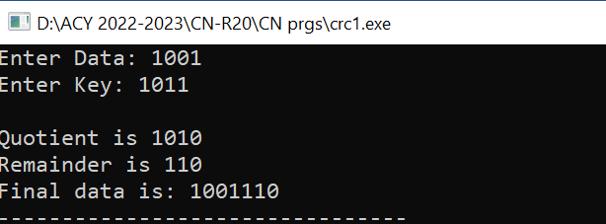

Week2: with another logic
//Implementation of CRC program

#include<stdio.h>
#include<string.h>
// length of the generator polynomial
#define N strlen(gen_poly)
// data to be transmitted and received
char data[28];
// CRC value
char check_value[28];
// generator polynomial
char gen_poly[10];
// variables
int data_length,i,j;
// function that performs XOR operation
void XOR(){
// if both bits are the same, the output is 0
// if the bits are different the output is 1
for(j = 1;j < N; j++)
check_value[j] = (( check_value[j] == gen_poly[j])?'0':'1');

}
// Function to check for errors on the receiver side
void receiver(){
// get the received data
printf("Enter the received data: ");
scanf("%s", data);
printf("\n-----------------------------\n");
printf("Data received: %s", data);
// Cyclic Redundancy Check
crc();
// Check if the remainder is zero to find the error
for(i=0;(i<N-1) && (check_value[i]!='1');i++);
if(i<N-1)
printf("\nError detected\n\n");
else
printf("\nNo error detected\n\n");
}

void crc(){
// initializing check_value
for(i=0;i<N;i++)
check_value[i]=data[i];
do{
// check if the first bit is 1 and calls XOR function
if(check_value[0]=='1')
XOR();
// Move the bits by 1 position for the next computation
for(j=0;j<N-1;j++)
check_value[j]=check_value[j+1];
// appending a bit from data
check_value[j]=data[i++];
}while(i<=data_length+N-1);
// loop until the data ends
}

int main()
{
// get the data to be transmitted
printf("\nEnter data to be transmitted: ");
scanf("%s",data);
printf("\n Enter the Generating polynomial: ");
// get the generator polynomial
scanf("%s",gen_poly);
// find the length of data
data_length=strlen(data);
// appending n-1 zeros to the data
for(i=data_length;i<data_length+N-1;i++)
data[i]='0';
printf("\n----------------------------------------");
// print the data with padded zeros
printf("\n Data padded with n-1 zeros : %s",data);
printf("\n----------------------------------------");
// Cyclic Redundancy Check
crc();
// print the computed check value
printf("\nCRC or Check value is : %s",check_value);
// Append data with check_value(CRC)
for(i=data_length;i<data_length+N-1;i++)
data[i]=check_value[i-data_length];
printf("\n----------------------------------------");
// printing the final data to be sent
printf("\n Final data to be sent : %s",data);
printf("\n----------------------------------------\n");
// Calling the receiver function to check errors
receiver();
return 0;
}

Output:-
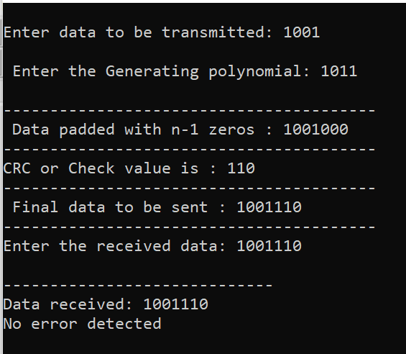

********************************************************************************
Week4:-
//Implement stop and wait protocols

#include<stdlib.h>
#include<conio.h>
int main()
{
int i,j,noframes,x,x1=10,x2;
printf("Enter no.of frames:");
scanf("%d",&noframes);
i=1;j=1;
printf("no.of frames is %d",noframes);
getch();
while(noframes!=0)
{
printf("\n sending frame is %d",i);
x=rand()%10;
if(x%10==0)
{
for(x2=1;x2<2;x2++)
{
printf("\n waiting for %d seconds\n",x2);
sleep(x2);
}
printf("\n sending frame %d\n",i);
x=rand()%10;
}
printf("\n ack for frame %d", j);
noframes=noframes-1;
i++;
j++;
}
printf("\nend of stop and wait protocol \n");
getch();
}

Output:-
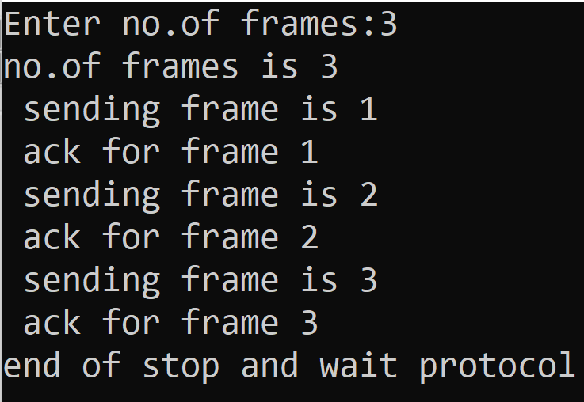

********************************************************************************

Week5:-
Implement GoBack-N and Selective Repeat Request protocol
//Goback-N protcol
#include<stdio.h>
#include<string.h>
void main()
{
int i=1;
int j=0;
int l,k=1;
int static s;
char x,t=1;
char str1[10];
char str2[20];
char str3[10];
printf("\n NOTE NOTE Data representatin is a=1,b=2......if u are sending characters\n");
printf("\n Sender Please Enter data:");
scanf("%s",str1);
x=str1[0];
printf("\n first character in sender data is:%c\n",x);
l=strlen(str1);
for(j=0;j<20;j++)
str2[j]='0';
str2[j]='\0';
while(k)
{
for(s=0,i=0,j=0;str1[i];i++,j++,x++)
{
if(str1[i]==x)
{
str2[j]=str1[i];
s=j;
}
else
continue;
}
for(i=0;str2[i];i++)
{
if(str2[i]=='0')
{
printf("\n sender please send the data from %d",++i);
break;
}
else
k=0;
}
}
printf("\n Enter missing data:");
scanf("%s",str3);
for(s=s+1,k=0;str3[k];k++,s++)
str2[s]=str3[k];
str2[s]='\0';
printf("\nsender string:%s Receiver string:%s\n",str1,str2);
}

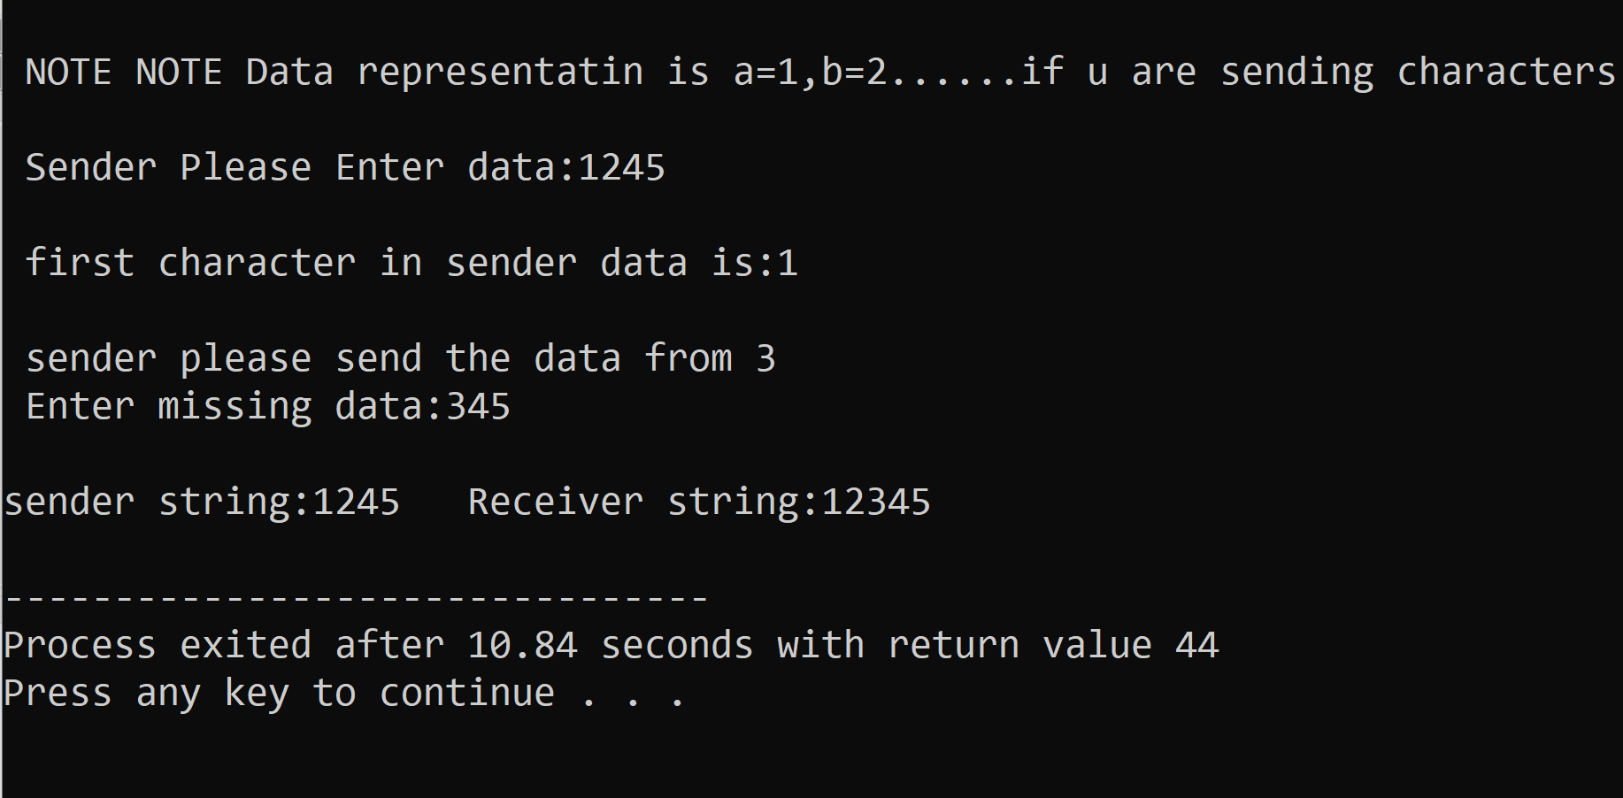
*****************************************************************************
//Selective repeat request protocols
//implement program on selective repeat

#include<stdio.h>
#include<conio.h>
#include<string.h>
void main()
{
char str1[20];
char str2[20];
int i=0;
int j=0;
char x;
//int t;
char c[2];
char ch;
//clrscr();
printf("\n NOTE NOTE THE PROGRAM IS SELECTIVE REPEAT \n");
printf("\n MEANS U CAN MISS ONE BYTE \n");
printf("\n SENDER please ENTER THE data:");
scanf("%s",str1);
for(i=0,x=str1[0];str1[i];i++,x++)
{
if(str1[i]==x)
continue;
else
{
printf("\n sender Please Enter the Missing data:%c",x);
break;
}
}
x=str1[0];
for(i=0,j=0;str1[i];i++,j++,x++)
{
if(str1[i]==x)
str2[j]=str1[i];
else
{
str2[j]='0';
i--;
}
}
str2[j]='\0';
for(i=0;str2[i];i++)
{
if(str2[i]!='0')
continue;
else
{
printf("\n Enter the missing data:");
scanf("%s",c);
c[1]='\0';
str2[i]=c[0];
}
}
printf("\n the sender data1:%s \n the Receiver data2:%s\n",str1,str2);
getch();
}

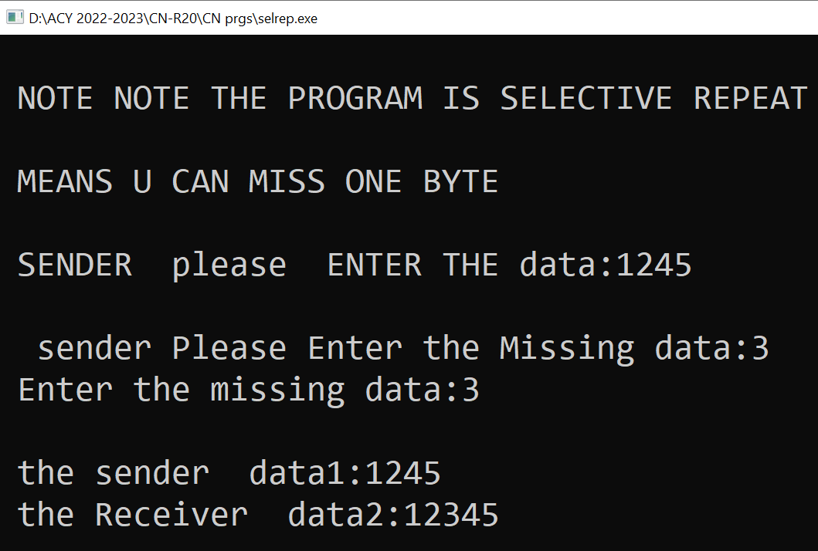

**********************************************************************************
Week6:-
Implement CSMA\CD using C program
// implementation of CSMA\CD
#include<stdio.h>
#include<stdlib.h>
#include<pthread.h>
#include<string.h>
#include<sys/time.h>
int x=0; //global variable X used for synchornization between threads
void capture()
{
exit(0);
}
int get() // get() used to manipulate the variable returns the global variable X
{
return x;
}
void put() //put() increments the value of the global variable X
{
x++;
}

void node(char *p) // represents network nodes behaviour it takes stirng argument P which
{ // represents the node’s name or identifier
int name;
int seq1, seq2, i=0;
long int t;
struct timeval tv;
struct timezone tz;
name=atoi(p);
while(1)
{
seq1=get();
seq2=get();
if(seq1==seq2) // if both seq1 and seq2 are equal it means the channel is idle. And the
{ // node transmits the frame
put();
seq1=get();
printf("station %d transmitting frame %d\n",name,++i);
sleep(3);
seq2=get();
if(seq1!=seq2) // if seq1 and seq2 are not equal it is collided and the node waits for a
{ // random amount of time
printf("station %d collision occured %d \n",name,i--);
sleep(3);
}
else
{
printf("station %d complete\n",name,i);
}
}
sleep(3);
}
}
main() // main() creates 3 threads using pthread_create to simulate 3 network nodes with name “1”. “2”, ‘’3’’
{
pthread_t t1,t2,t3;
pthread_create(&t1,0,(void *)node,"1");
pthread_create(&t2,0,(void *)node,"2");
pthread_create(&t3,0,(void *)node,"3");
while(1); // while loop in main() keeps the program running indefinitely.
}

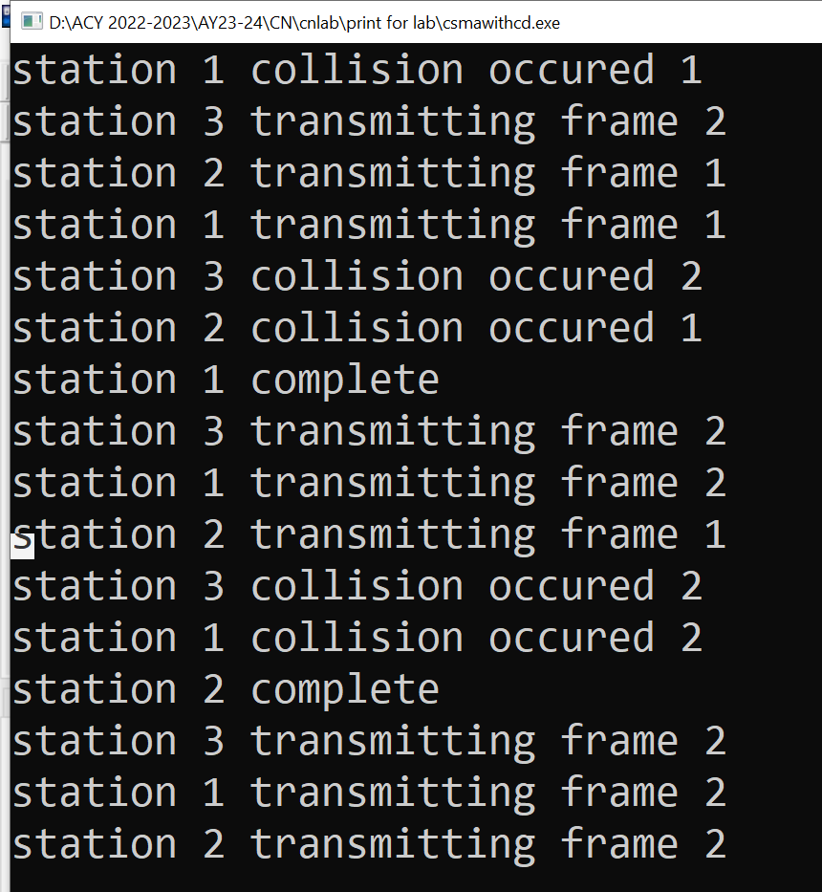

Explanation:-
- Pthread_t is a datatype which uniquely identifies a thread and it is returned by pthread_create.
- int pthread_create(pthread_t *thread, const pthread_attr_t *attr, void *(*start_routine)(void *), void *arg);

pthread_create(&t1,0,(void *)node,"1");
***************************************************************************

Week7:-
Implement CSMA/CA in c program

#include <stdio.h>
#include <unistd.h>
#include <stdlib.h>
#include <string.h>
#include <pthread.h>
#define threads 3
void *thread_fun(void *arg);
int main()
{
int res;
pthread_t a_thread[threads]; // creating threads as arrays
void *thread_res;
int lt;
int tt;
for (lt = 0; lt < threads; lt++)
{
res = pthread_create(&(a_thread[lt]), NULL, thread_fun, (void *)lt); // returns 0 on success 1 on Failure
if (res != 0)
{
perror("thread creation failed");
exit(EXIT_FAILURE);
}
}
printf("Waiting for stations to finish..........\n");
for (lt = threads - 1; lt >= 0; lt--)
{
res = pthread_join(a_thread[lt], &thread_res); // returns 0 on success 1 on Failure
if (res == 0)
printf("\n station got the channel");
else
perror("\nstations failed DUE TO COLLISION to get channel");
}
printf("\n .....all stations done\n");
exit(EXIT_SUCCESS);
}

void *thread_fun(void *arg) // (function to avoid Collision) serves as the entry point for each thread (station). It will be executed when a new thread is created.
{
int my_number = (int)arg; // Convert station's channel
int r_num;
printf("\n Station is accessing the channel. Station number is %d\n", my_number);
r_num = 1 + (int)(9.0 * rand() / (RAND_MAX + 1.0));
sleep(r_num);
printf("\n Bye From Station %d access completed", my_number);
pthread_exit(NULL);
}
Output:-
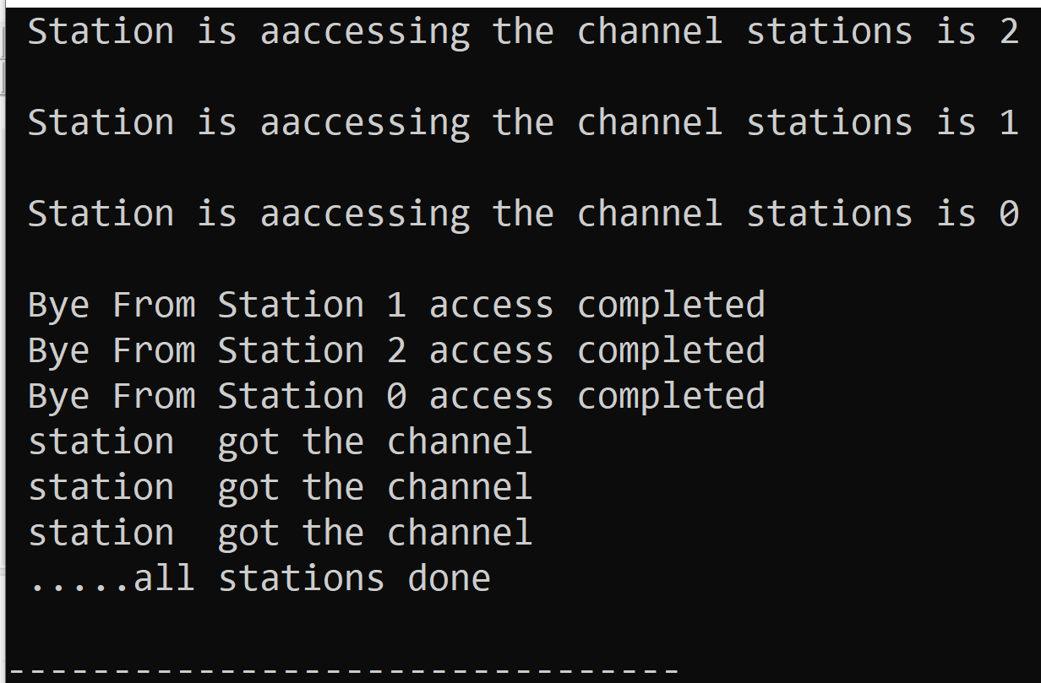

Pthread.h :-

- pthread_create: used to create a new thread
syntax:-
int pthread_create(pthread_t * thread,
const pthread_attr_t * attr,
void * (*start_routine)(void *),
void *arg);
- thread: pointer to an unsigned integer value that returns the thread id of the thread created.
- attr: pointer to a structure that is used to define thread attributes like detached state, scheduling policy, stack address, etc. Set to NULL for default thread attributes.
- start_routine: pointer to a subroutine that is executed by the thread. The return type and parameter type of the subroutine must be of type void *. The function has a single attribute but if multiple values need to be passed to the function, a struct must be used.
- arg: pointer to void that contains the arguments to the function defined in the earlier argument

2) pthread_exit: used to terminate a thread
Syntax:
void pthread_exit(void *retval);

This method accepts a mandatory parameter retval which is the pointer to an integer that stores the return status of the thread terminated. The scope of this variable must be global so that any thread waiting to join this thread may read the return status.

3) pthread_join: used to wait for the termination of a thread.
Syntax:
int pthread_join(pthread_t th, void **thread_return);
Parameter: This method accepts following parameters:
- th: thread id of the thread for which the current thread waits.
- thread_return: pointer to the location where the exit status of the thread mentioned in th is stored.

4) The function rand() is used to generate the pseudo random number. It returns an integer value and its range is from 0 to rand_max i.e 32767.

This code represents a simple simulation of multiple stations trying to access a shared communication channel in a computer network. Let's break it down:

1. The code includes necessary header files for standard input/output, thread management, sleep functionality, and random number generation.

2. `#define threads 3` defines a constant named `threads` with a value of 3. This indicates that there are three stations trying to access the channel in the simulation.

3. The code defines a function `void *thread_fun(void *arg)` that serves as the entry point for each thread (station). It will be executed when a new thread is created.

4. In the `main` function:
- It declares variables `res`, `a_thread`, `thread_res`, `lt`, and `tt`.
- `pthread_t a_thread[threads];` creates an array of thread identifiers, `a_thread`, to keep track of the created threads.
- It then starts a loop from 0 to `threads-1`, where `threads` is 3 in this case.
- In each iteration, it creates a new thread using `pthread_create` and assigns the thread ID to `a_thread[lt]`. It also passes `lt` as an argument to the thread function `thread_fun`. This argument represents the station number.
- If `pthread_create` returns a non-zero value, it means the thread creation failed, and the program prints an error message and exits.

5. After creating all the threads, the program prints "Waiting for stations to finish..........".

6. The program then enters another loop, starting from `threads-1` and decreasing `lt` until it reaches 0. This loop waits for each thread to finish its execution using `pthread_join`.
- `pthread_join` blocks the program's execution until the specified thread (station) finishes. The result of the thread function is stored in `thread_res`.
- If `pthread_join` returns 0, it means the thread has successfully finished, and the program prints "station got the channel".
- If `pthread_join` returns a non-zero value, it means the thread couldn't complete its execution properly, possibly due to a collision while accessing the channel. The program then prints an error message indicating the collision.

7. After all the threads have finished execution and been joined, the program prints ".....all stations done" and exits successfully.

8. The thread function `thread_fun` represents the behavior of each station:
- It takes a single argument `arg`, which is cast to an integer to represent the station number (`my_number`).
- It prints a message indicating that the station is accessing the channel with its number.
- It generates a random number `r_num` between 1 and 9, sleeps for that number of seconds, simulating the time the station uses the channel.
- After sleeping, it prints a message indicating that the station's access is completed.

Overall, this code simulates multiple stations trying to access a shared channel, and each station spends a random amount of time on the channel before completing its access. If there is a collision and a station cannot access the channel, the program detects it during the join operation and prints an error message accordingly.
********************************************************************************************

Week8:-
Study and installation of simulation tool and its features

